2.3 Arc Length & Change of Parameter
Recall: In calculus II you probably were introduced to the formula for the length of a parametric curve in two dimensions. Since the distance formula in three dimensions is very closely related to the distance formula in two dimensions, this formula extends nicely in the 3-dimensional case. However, before we present this formula we introduce some terminology.

Definition: A parameterization is called smooth on an interval I if is continuous and for any t on I. A curve is smooth if it has a smooth parameterization. A smooth curve has no sharp corners or cusps.

Theorem: Suppose that is a smooth vectored-value function for , where the curve is only traversed one time as t goes from a to b then

.

Partial Proof:

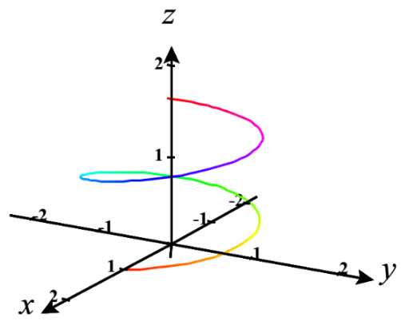
Suppose we have a smooth vector-valued function given by where .
We will begin by dividing the interval into n subintervals of equal length and connect the endpoints of these subintervals with line segments to approximate the length of the curve.

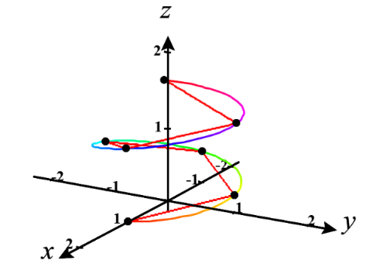
We measure the length of any given line segment by creating a vector between the endpoints, which we will call , and calculating its magnitude. From this we obtain that .

Therefore, we estimate the total length of the vector function to be .

With a much more complicated argument it can be shown that the FTOC and the MVT can be used to establish that
(this argument is beyond the scope of this course)

Therefore .
We therefore expect that as we will obtain the exact arc length.

So, we have

Example 1: Find the length of the curve determined by from the point and .

We first note that the curve is traversed once as t increases from 0 to .
We note that .
So, is clearly continuous from 0 to and also on 0 to .
So, the desired length is:
.

Definition: Suppose a curve C is given by where where is continuous and C is traversed exactly once as t increases from a to b. We define the arc length function of C to be
for t in .

Note: Intuitively the arc length function of C takes in t and spits out the length of the part of C traversed from a to t.
Remark: By the fundamental theorem of calculus . Therefore, as we will see later in Chapter 5, the arc length integral is sometimes written as .
Example 2: Suppose C is given by where . Find the arc length function of C.

Since this is the curve from Example 1 we already checked the necessary conditions. So, by definition:
where .

In the past several sections we have communicated curves in 3-space using parametric equations which used a parameter of t that we commonly thought of as representing time. However, it can be helpful to change parameters so that we can measure motion along a curve not just by some value of time. Specifically, it will be helpful to measure motion along a curve in terms of the distance we have travelled from some fixed starting point, that is to say, using arc length.

Definition: Suppose a curve C is given by with where r is a smooth vector-valued function and C is traversed exactly once as t increases from a to b. If from the arc length function for we can solve for t to obtain t as a function of s, then the arc length parameterization of C is .

Steps to Obtaining an Arc Length Parameterization for a Curve:
- Find the arc length function of C, .
- Use to solve for t in terms of s (this may not be possible). Then, you have t as a function of s.
- Simply use composition of functions to obtain your arc length parameterization: .

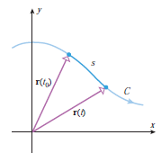
Remark: The power in the arc length parameterization is that if your plug a number like 2 into it, it will spit out a position vector whose terminal point is the point at which a particle which started its movement at the initial point of C is located after it has traveled 2 units along C.

Example 3: Suppose C is given by where .
- Find an arc length parameterization of C.

We know from the previous example that . This implies that , and the arc length parameterization is .

- Plug into the parameterization you found in (a). Look back in your notes to see why the result that you get is awesome.

We calculate , and we know from the second to last example that the terminal point of this position vector is where one must travel on the curve from to get a length of !

